**Simulation of matrix pipeline (10x10)**

1cc: Fetch + multiply

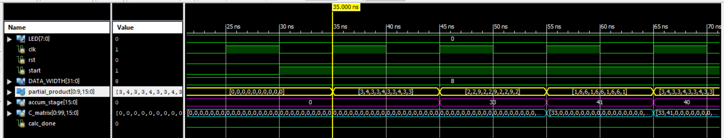

2cc: (Fetch + multiply), accumulate

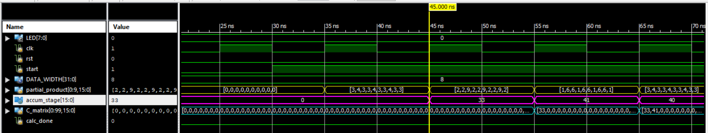

2cc: (Fetch + multiply), accumulate, store

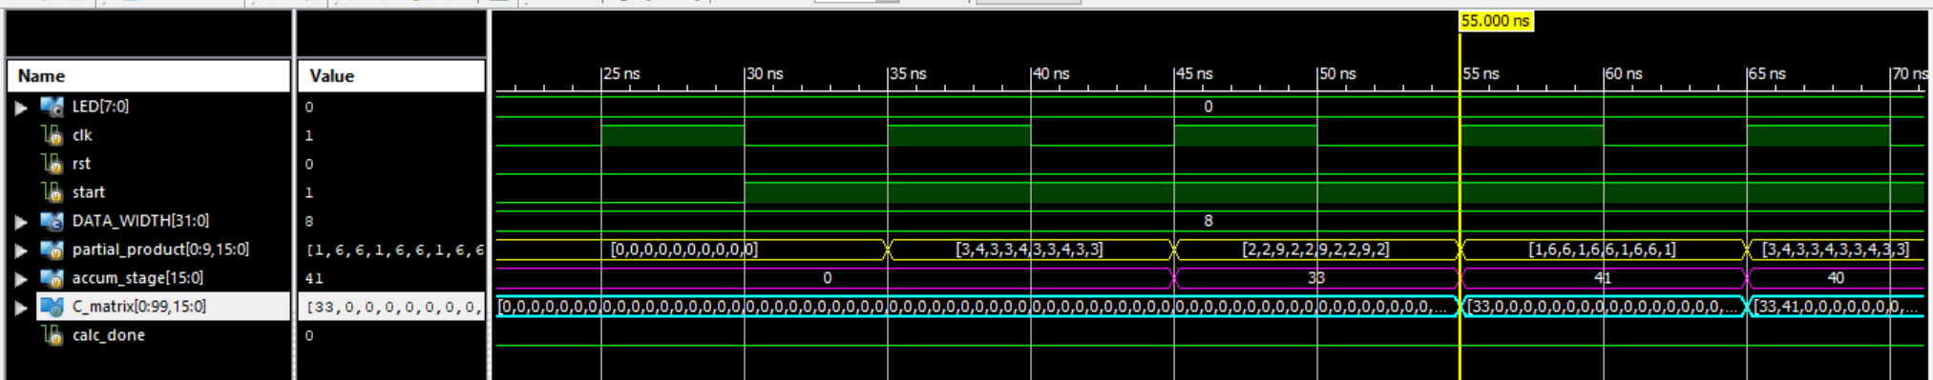

Final result when matrix calculation is done (cal_done signal high)

